Right Quadrilateral Pyramid
# Source: AI Source: Provided by: [Data Path: Persons Table -> ID Column: 1, Name_En Column: Motasem Essam] -> From: [ChatGPT] on [7/25/2026]
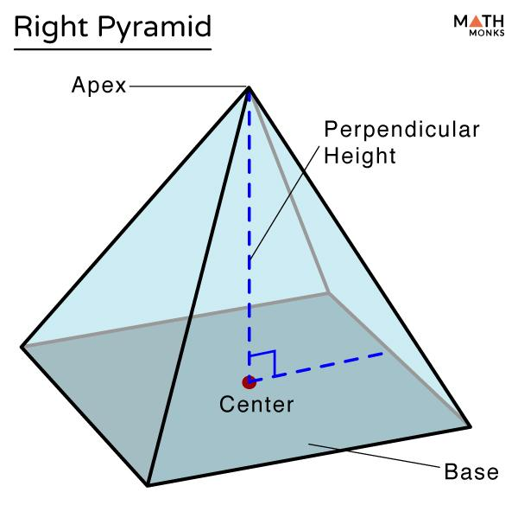
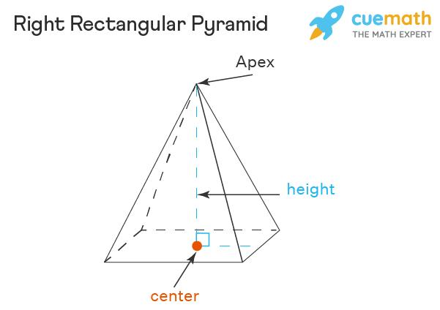
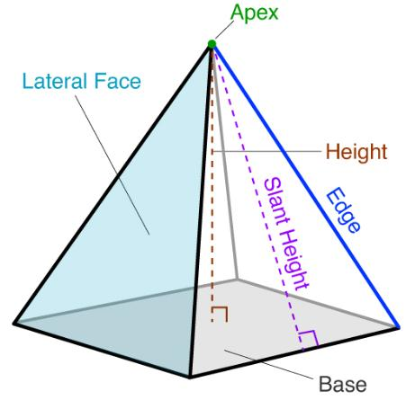

Definition
# Source: AI Source: Provided by: [Data Path: Persons Table -> ID Column: 1, Name_En Column: Motasem Essam] -> From: [ChatGPT] on [7/25/2026]
A right quadrilateral pyramid is a three-dimensional geometric solid with a quadrilateral base and an apex positioned directly above the designated center of the base, so that the perpendicular from the apex to the base plane meets that center.
The base can be a square, rectangle, rhombus, parallelogram, or trapezoid. The exact meaning of center must be specified for an irregular quadrilateral, because different definitions of center may not coincide.
A right quadrilateral pyramid has:
- 1 quadrilateral base.
- 4 triangular lateral faces.
- 5 faces in total.
- 8 edges in total.
- 5 vertices in total.
Important distinction: Right describes the position of the apex relative to the base. It does not mean that the base must be a rectangle or that every lateral face must be a right triangle.

Simple Definition
# Source: AI Source: Provided by: [Data Path: Persons Table -> ID Column: 1, Name_En Column: Motasem Essam] -> From: [ChatGPT] on [7/25/2026]
A right quadrilateral pyramid is a pyramid with a four-sided base whose apex is directly above the designated center of the base, with the pyramid's height perpendicular to the base.

Key Characteristics
# Source: AI Source: Provided by: [Data Path: Persons Table -> ID Column: 1, Name_En Column: Motasem Essam] -> From: [ChatGPT] on [7/25/2026]
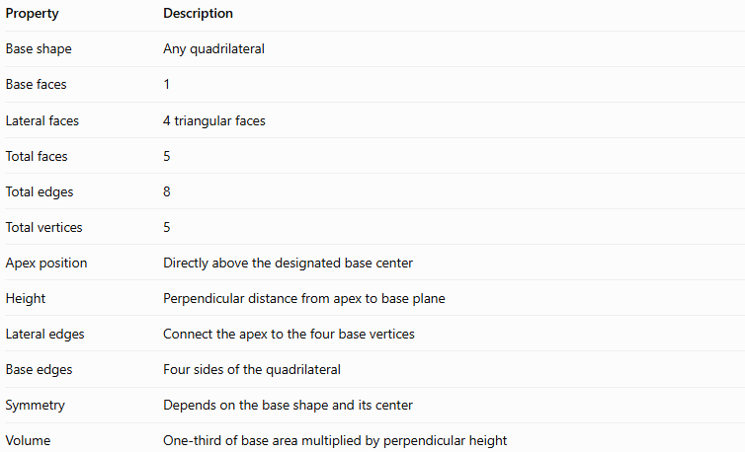
Property | Description
Base shape | Any quadrilateral
Base faces | 1
Lateral faces | 4 triangular faces
Total faces | 5
Total edges | 8
Total vertices | 5
Apex position | Directly above the designated base center
Height | Perpendicular distance from apex to base plane
Lateral edges | Connect the apex to the four base vertices
Base edges | Four sides of the quadrilateral
Symmetry | Depends on the base shape and its center
Volume | One-third of base area multiplied by perpendicular height

Geometric Representation
# Source: AI Source: Provided by: [Data Path: Persons Table -> ID Column: 1, Name_En Column: Motasem Essam] -> From: [ChatGPT] on [7/25/2026]
The main components are:
- Base: The quadrilateral at the bottom.
- Apex: The vertex positioned above the designated center of the base.
- Base edges: The four edges forming the quadrilateral.
- Lateral edges: The four segments joining the apex to the base vertices.
- Lateral faces: The four triangles connecting the base edges to the apex.
- Height: The perpendicular segment from the apex to the base plane.
- Base center: The point where the height meets the base under the chosen convention.
For a square base, the center is the intersection of its diagonals. For a rectangular base, it is also the intersection of the diagonals. For other quadrilaterals, the relevant center should be specified.

Mathematical Representations and Formulas
# Source: AI Source: Provided by: [Data Path: Persons Table -> ID Column: 1, Name_En Column: Motasem Essam] -> From: [ChatGPT] on [7/25/2026]
Let:
- $B$ = area of the quadrilateral base.
- $P$ = perimeter of the base.
- $H$ = perpendicular height of the pyramid.
- $A_{L}$ = lateral surface area.
- $A_{T}$ = total surface area.

Base Area
# Source: AI Source: Provided by: [Data Path: Persons Table -> ID Column: 1, Name_En Column: Motasem Essam] -> From: [ChatGPT] on [7/25/2026]
The base area depends on the quadrilateral.
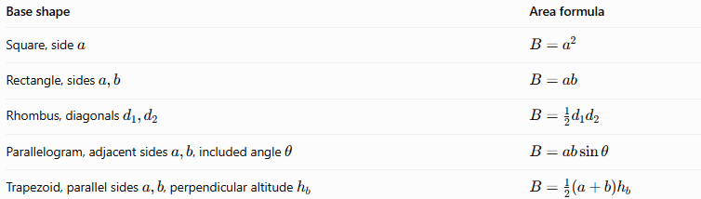
Base shape | Area formula
Square, side $a$ | $$B=a^{2}$$
Rectangle, sides $a,b$ | $$B=ab$$
Rhombus, diagonals $d_{1},d_{2}$ | $$B=\frac{1}{2}d_{1}d_{2}$$
Parallelogram, adjacent sides $a,b$, included angle $θ$ | $$B=ab\sin{θ}$$
Trapezoid, parallel sides $a,b$, perpendicular altitude $h_{b}$ | $$B=\frac{1}{2}\left(a+b\right)h_{b}$$

Volume
# Source: AI Source: Provided by: [Data Path: Persons Table -> ID Column: 1, Name_En Column: Motasem Essam] -> From: [ChatGPT] on [7/25/2026]
The volume of any pyramid is one-third of the product of its base area and perpendicular height:
$$\boxed{V=\frac{1}{3}BH}$$
This formula applies to both right and oblique pyramids.

Lateral Surface Area
# Source: AI Source: Provided by: [Data Path: Persons Table -> ID Column: 1, Name_En Column: Motasem Essam] -> From: [ChatGPT] on [7/25/2026]
The lateral surface area is the sum of the areas of the four triangular faces:
$$\boxed{A_{L}=A_{1}+A_{2}+A_{3}+A_{4}}$$
For each triangular face:
$$A_{i}=\frac{1}{2}s_{i}l_{i}$$
where $s_{i}$ is the corresponding base-edge length and $l_{i}$ is the perpendicular altitude of that triangular face.
A right pyramid does not necessarily have one common slant height for all four faces. That simplification is valid only when the geometry supports it.

Total Surface Area
# Source: AI Source: Provided by: [Data Path: Persons Table -> ID Column: 1, Name_En Column: Motasem Essam] -> From: [ChatGPT] on [7/25/2026]
$$\boxed{A_{T}=B+A_{L}}$$
The total surface area includes the quadrilateral base and all four triangular lateral faces.

Special Case: Right Square-Base Pyramid
# Source: AI Source: Provided by: [Data Path: Persons Table -> ID Column: 1, Name_En Column: Motasem Essam] -> From: [ChatGPT] on [7/25/2026]
For a right square-base pyramid with base side $a$ and perpendicular height $H$, the four lateral faces are congruent isosceles triangles.
The slant height is:
$$l=\sqrt{H^{2}+{\left(\frac{a}{2}\right)}^{2}}$$
The lateral surface area is:
$$\boxed{A_{L}=2al}$$
The total surface area is:
$$\boxed{A_{T}=a^{2}+2al}$$
The volume is:
$$\boxed{V=\frac{1}{3}a^{2}H}$$
These simplified surface-area formulas apply specifically to the right square-base case, not to every right quadrilateral pyramid.

Euler’s Formula
# Source: AI Source: Provided by: [Data Path: Persons Table -> ID Column: 1, Name_En Column: Motasem Essam] -> From: [ChatGPT] on [7/25/2026]
A convex right quadrilateral pyramid satisfies Euler’s formula:
$$V_{e}-E+F=2$$
Substituting its counts:
$$5-8+5=2$$
Here, $V_{e}$ denotes the number of vertices, not the volume.

Worked Examples
# Source: AI Source: Provided by: [Data Path: Persons Table -> ID Column: 1, Name_En Column: Motasem Essam] -> From: [ChatGPT] on [7/25/2026]
Example 1: Finding the Volume
A right quadrilateral pyramid has a rectangular base measuring $8\text{ cm}$ by $6\text{ cm}$ and a perpendicular height of $9\text{ cm}$. Find its volume.
First, calculate the base area:
$$B=8×6=48{\text{ cm}}^{2}$$
Then calculate the volume:
$$V=\frac{1}{3}BH$$
$$V=\frac{1}{3}\left(48\right)\left(9\right)$$
$$\boxed{V=144{\text{ cm}}^{3}}$$
Example 2: Finding the Slant Height of a Right Square-Base Pyramid
A right square-base pyramid has a base side of $10\text{ cm}$ and a perpendicular height of $12\text{ cm}$. Find the slant height of a lateral face.
Use:
$$l=\sqrt{H^{2}+{\left(\frac{a}{2}\right)}^{2}}$$
Substitute:
$$l=\sqrt{{12}^{2}+5^{2}}$$
$$l=\sqrt{144+25}$$
$$\boxed{l=13\text{ cm}}$$
Example 3: Finding the Total Surface Area
Using the pyramid from Example 2, calculate its total surface area.
The base area is:
$$B={10}^{2}=100{\text{ cm}}^{2}$$
The lateral surface area is:
$$A_{L}=2al$$
$$A_{L}=2\left(10\right)\left(13\right)=260{\text{ cm}}^{2}$$
Therefore:
$$A_{T}=B+A_{L}$$
$$A_{T}=100+260$$
$$\boxed{A_{T}=360{\text{ cm}}^{2}}$$
Example 4: Counting Faces, Edges, and Vertices
Because the pyramid has a quadrilateral base, $n=4$.
For an $n$-sided pyramid:
$$F=n+1, E=2n, V_{e}=n+1$$
Therefore:
$$F=5, E=8, V_{e}=5$$
Answer: 5 faces, 8 edges, and 5 vertices.

Comparison with Related Pyramids
# Source: AI Source: Provided by: [Data Path: Persons Table -> ID Column: 1, Name_En Column: Motasem Essam] -> From: [ChatGPT] on [7/25/2026]
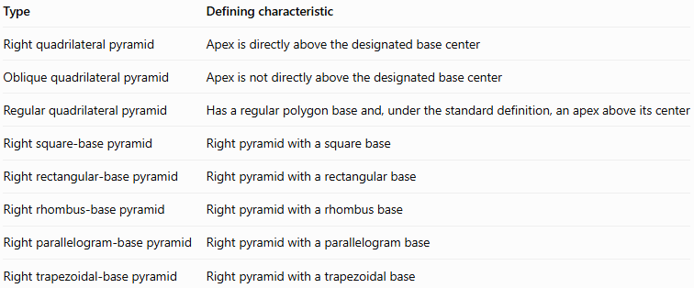
Type | Defining characteristic
Right quadrilateral pyramid | Apex is directly above the designated base center
Oblique quadrilateral pyramid | Apex is not directly above the designated base center
Regular quadrilateral pyramid | Has a regular polygon base and, under the standard definition, an apex above its center
Right square-base pyramid | Right pyramid with a square base
Right rectangular-base pyramid | Right pyramid with a rectangular base
Right rhombus-base pyramid | Right pyramid with a rhombus base
Right parallelogram-base pyramid | Right pyramid with a parallelogram base
Right trapezoidal-base pyramid | Right pyramid with a trapezoidal base
Important distinction: Every regular square-base pyramid is a right quadrilateral pyramid, but not every right quadrilateral pyramid is regular. For example, a right pyramid with a rectangular base that is not a square is not a regular pyramid.

Applications
# Source: AI Source: Provided by: [Data Path: Persons Table -> ID Column: 1, Name_En Column: Motasem Essam] -> From: [ChatGPT] on [7/25/2026]
Right quadrilateral pyramids are useful in:
- Architecture: Designing pyramid-shaped roofs and structures with quadrilateral footprints.
- Engineering: Modeling tapered structures and calculating volume and material requirements.
- CAD and 3D modeling: Creating solids with controlled apex placement.
- Geometry education: Studying perpendicular height, slant height, surface area, and volume.
- Spatial reasoning: Comparing right and oblique solids and examining symmetry.

Key Points
# Source: AI Source: Provided by: [Data Path: Persons Table -> ID Column: 1, Name_En Column: Motasem Essam] -> From: [ChatGPT] on [7/25/2026]
- A right quadrilateral pyramid has a four-sided base and four triangular lateral faces.
- It has 5 faces, 8 edges, and 5 vertices.
- Its apex lies directly above the designated center of the base.
- Its perpendicular height meets the base plane at that center.
- The base may be a square, rectangle, rhombus, parallelogram, or trapezoid.
- Its volume is $V=\frac{1}{3}BH$.
- Its lateral surface area is the sum of the four triangular face areas.
- A common slant-height formula cannot be applied indiscriminately to every quadrilateral base.
- A right pyramid is not automatically a regular pyramid.

Conclusion
# Source: AI Source: Provided by: [Data Path: Persons Table -> ID Column: 1, Name_En Column: Motasem Essam] -> From: [ChatGPT] on [7/25/2026]
A right quadrilateral pyramid is a three-dimensional polyhedron with a quadrilateral base and an apex positioned directly above the designated base center. Its defining feature is the perpendicular alignment of the apex with that center, rather than the specific shape of the base.
It has five faces, eight edges, and five vertices. Its volume is calculated using one-third of the base area multiplied by its perpendicular height, while its surface area depends on the dimensions of the base and the four triangular lateral faces. A right square-base pyramid is a particularly useful special case because its lateral faces are congruent and its surface-area calculations can be simplified.

